**Course Syllabus**

**Medical Interventions**

**Instructor: Katie Weir**

**Dear Parent/Guardian,**

I look forward to having a great year! I feel fortunate to have your student in my class this semester. I hope that you will contact me if you have any concerns about the progress of your student, or any aspect of the instruction.

Along with your student please read the syllabus and lab safety contract linked in Schoology or via the QR code on this page. Then complete this signed classroom/lab contract paper form. Please provide a current email address and phone number at which I can contact you should the need arise.

Thank you,

Mrs. Katie Weir

kmweir2@madisoncity.k12.al.us

**Syllabus QR Code Safety Contract QR Code**

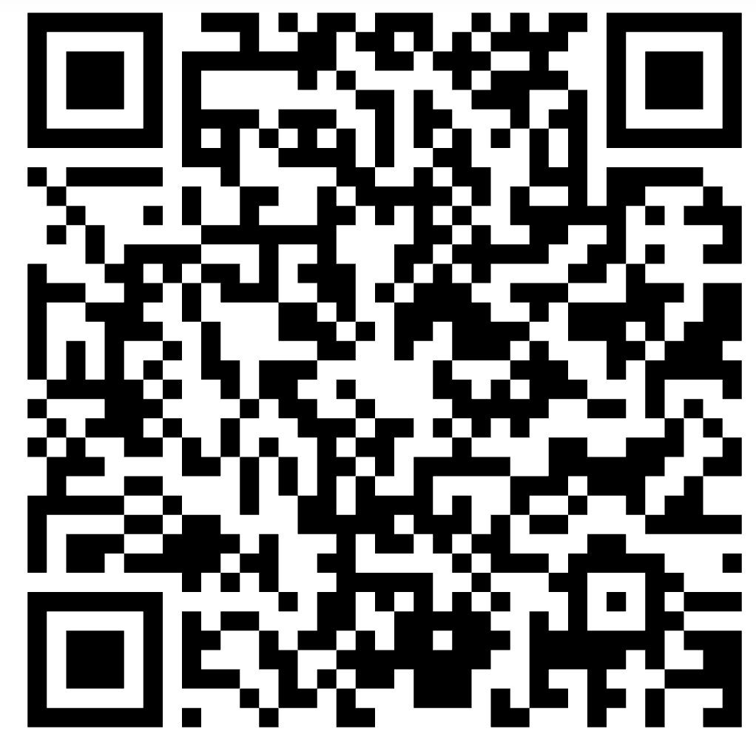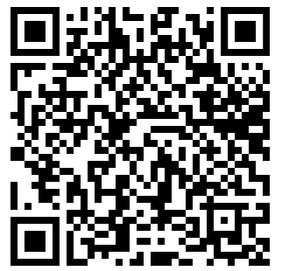

**My student and I have read and discussed the classroom syllabus.**

By signing this you also give permission for your student to participate in all classroom activities and labs.

Student Name (Print) _____________________________________ Date ____________

Student Signature ________________________________________ Date ____________

Parent/Guardian Name (Print) ______________________________ Date ____________

Parent/Guardian Signature _________________________________ Date ____________

Parent/Guardian Email Address(es)_________________________________________________

Best Phone number __________________

Anything you would like me to know about your student:

**Course Syllabus**

**Medical Interventions**

**Instructor: Katie Weir**

**Course Description:**

In the Medical Interventions course, students will investigate the variety of interventions involved in the prevention, diagnosis and treatment of disease as they follow the lives of a fictitious family. A “How-To” manual for maintaining overall health and homeostasis in the body, the course will explore how to prevent and fight infection, how to screen and evaluate the code in our DNA, how to prevent, diagnose and treat cancer, and how to prevail when the organs of the body begin to fail. Through these scenarios, students will be exposed to the wide range of interventions related to Immunology,

Surgery, Genetics, Pharmacology, Medical Devices, and Diagnostics.

**Course Objectives:**

**Students will:**

1) Students will utilize concepts learned in the previous biomedical courses as they seek medical interventions for the family case scenarios.   
2) Students will research various types of medical interventions from simple diagnostic tests to treatment of complex diseases and disorders.   
3) Students will explore the role of lifestyle choices and preventive measures as well as scientific thinking and engineering design as they examine all medical interventions in healthcare.

**Classroom Rules and Expectations:**

1. **BE ON TIME**. Tardy means that you are not **in the room** and getting seated when the bell rings. If you are not in the room when the tardy bell rings, you will need to go to the attendance office for a tardy slip. *JCHS policy governs the consequences for tardiness*.

2. **BE RESPECTFUL**: Practice courtesy and mutual respect. Treat others as you would like to be treated. The classroom and laboratory is to be regarded as a safe and supportive learning environment. You will work with people you do not know at some point - it is an assignment, not marriage.

3. **BE YOUR OWN PERSON:** Many assignments are to be completed by lab partners or within a group. However, **ALL students are expected to contribute and/or work is to be done individually**. Plagiarizing/copying assignments from lab partners is not acceptable and can result in a zero on the assignment.

4. **BE PREPARED:** Come prepared for class—mentally and with proper materials. Please try to take care of any personal business before or after class. I do not want you to miss valuable class time!

5. **BE WHERE YOUR FEET ARE:** Anything distracting to you, your classmates, or your teacher should be put away during class (devices, food, candy, drinks, etc**.)**

**Please refer to the** [**MCS Student Code of Conduct**](https://www.madisoncity.k12.al.us/Page/1125) **for all district policies and procedures (including devices and AI). You are responsible for knowing and following the student code of conduct.**

**Classroom Management Plan:**

1. Verbal reprimand
2. Conference with student with parent contact
3. Withdrawal of privilege(s) with parent contact
4. Other consequences determined to be reasonable and appropriate by the school administration.

**CTSO**: Students are encouraged to participate in HOSA. Competitive events that relate to a specific topic discussed in class will be highlighted.

**Culminating Product:** Basis of knowledge required in preparation for Medical Interventions (MI).

**Career Readiness Indicator:** Students who are age 15 and older and meet the American Red Cross requirements for Lifeguarding are eligible to receive this credential paid for by the Alabama State Department of Education. See Mrs. Weir for further details.

**BACE Credential:**  MI students will take the BACE (Biotechnology Aptitude and Competency Exam) at the end of the course. BACE is an industry-recognized exam offered by Biotility designed to assess core skills and knowledge sets defined by the bioscience industry. The exam framework is based on a DACUM analysis, detailing the competencies foundational to technician level positions. Reviewed and updated annually with oversight from a national advisory board, the BACE remains current to industry needs nationwide. The Biotechnical credential is an industry-recognized credential that documents mastery of the core skills and knowledge valued for entry-level technician positions in the bioscience industry (including, but not limited to: quality control technician, research technician, process technician, specimen collector, and more). The BACE is used as a hiring benchmark nationwide — credential earners require less training than their counterparts, which allows for nearly seamless onboarding. (https://biotility.research.ufl.edu/bace/)

**Accommodations:** Requests for accommodations for this course or any school event are welcomed from students and parents.

**Concerning Laptop Utilization:** Student laptops should not be hard-wired to the network or have print capabilities. 2. Use of discs, flash drives, jump drives, or other USB devices will not be allowed on Madison City computers. 3. Neither the teacher, nor the school is responsible for broken, stolen, or lost laptops. 4. Laptops and other electronic devices will be used at the individual discretion of the teacher.

**Turnitin Notice:** Some writing assignments in this course may be submitted to Turnitin via the Schoology learning platform. The primary focus of this software is to help students become better writers and scholars. Turnitin generates a report on the originality of student writing by comparing it with a database of periodicals, books, online content, student papers, and other published work. This program will help students discern when they are using sources fairly, citing properly, and paraphrasing effectively - skills essential to all academic work.

Students will have the opportunity to review their Turnitin originality report and will have the opportunity to make revisions before submitting their work for grading. Once their work is submitted, teachers have the opportunity to view the student's originality report and grade accordingly.

**Grading Policy:**

Test/project grades will account for 70% of the 9-weeks grade, with the remaining 30% being determined by quiz/daily grades. Some quizzes will count as test grades. The grading scale is as follows: A (90-100%), B (80-89), C (70-79), D (65-69), and F (below 65). Grades will be a reflection of mastery of the standards. Make sure all absences are excused as class work can be made up and graded for excused absences only.   
The final exam counts for 20% of the final grade.

There will be several projects assigned. Students should be prepared to work in the home with one to several students. All safety rules learned in class should be applied at home. Be aware that some of the materials students use at home may damage household contents. Students should be thoughtful of their working environment.

**Make-Up Work Policy:**

Attendance is crucial for success in MI as most of the work will be done in class and many of the activities are difficult to make up.

It is the **student’s** responsibility to collect assignments that are missed during an absence from Schoology, another student, or by contacting the teacher. **Students have the same number of days they were absent to make up an assignment/activity.**  Note: Certain lab activities cannot be made up due to logistical issues, and students will be given a possible alternate assignment to replace the lab grade.

Tests & quizzes that are missed will be completed outside of instructional/activity time. Please talk to me to set up a time to make up your assignment during Refuel. It is the **student’s** responsibility to set up a time and make up your test or quiz.

Late work will be accepted with the penalty of 20% deducted per day late for the maximum of 5 school days, but students must discuss turning in late work. **Late work will not be accepted after 1 week after the due date.**

Please monitor the Schoology calendar and classroom board for deadlines. Enable notifications on Schoology to get reminders!

**Unexcused Absences**

It is very important that you get all absences excused. If you do not, the computer will not allow me to enter a grade above a zero for any given assignment on the day you missed. It is **your** responsibility to take care of this and to let me know when the excuse has been updated. I do not receive notifications that absences have been excused.

**MCS Final Exam Exemption Policy:** Any student in grades 9-12 are eligible to earn an exam exemption for semester exams for each class.

Students are eligible to exempt a final exam if they have earned an **85% or higher as the final grade** for that course.

Any of the following will EXCLUDE a student from exempting the exam for that class:

* More than five EXCUSED absences (includes doctor notes)
* Any UNEXCUSED absence
* Assignment to In School Suspension (ISS) for 3 days or more
* Any Out of School Suspension (OSS)
* One or more days of Alternative School placement
* Not participating in the state standardized assessment for their grade level including all subtests (10th PreACT, 11th ACT with Writing, 12th WorkKeys)

Attendance and full participation in reviews and assignments for the class leading up to the day of the final exam are required.

**Course Materials:**

*Per Individual:*

One 1½-2 inch three ring binder* Black/Blue ink pens & Pencils

Loose leaf paper Graph paper

Roll of paper towelsDividers

Colored pencils Laptop (school issued or classroom set)

Scientific Calculator

*Wishlist Items:*

Pack of copy paper Hand sanitizer

Sanitizing wipes Dishwashing liquid

Tissues Handsoap

**Texts/Required Readings:**

The course is online and the majority of the materials that accompany this class will be accessible online.

**Embedded Numeracy and Literacy**

Opportunities for numeracy and literacy in the CTE class are critical and help support the goals of CTE in preparing students for college and/or career. Example anchor activities for mathematics include performing various calculations such as serial dilutions and Beer’s Law; analyzing data collected from laboratory application and research. Example anchor activities for literacy include: Reading scientific articles, interviewing various medical professionals, investigating various STEM fields and describing their responsibilities and the requirements to enter the field, writing a design brief or other science laboratory report.

**Technical Writing**

Students will learn to select and use appropriate language and layout for technical documents and write documents that are clear, accurate, and grammatically correct.

| **18 - WEEK PLAN\*** | |
| --- | --- |
| **WEEK 1** | Introduction  **Unit One: How to Fight Infection (22.5 Days)**  **Lesson 1.1: The Mystery Infection (8.5 Days)**  Activity 1.1.1 - Medical Interventions Inventory  Activity 1.1.2 - Investigating an Outbreak  Problem 1.1.3 - Using DNA to Identify Pathogens |
| **WEEK 2** | Activity 1.1.4 - What’s the Concentration? (**Optional**, additional 1.5 days)  Activity 1.1.5 – ELISA  Activity 1.1.6 - Final Diagnosis |
| **WEEK 3** | **Lesson 1.2: Antibiotic Treatment (4.5 Days)**  Activity 1.2.1 - Antibiotic Therapy  Activity 1.2.2 – Which Antibiotic is the Best Choice?  Project 1.2.3 - Attack of the Superbugs  Activity 1.2.4 - When Antibiotics Fail |
| **WEEK 4** | **Lesson 1.3: The Aftermath: Hearing Loss (5 Days)**  Activity 1.3.1 - Good Vibrations  Activity 1.3.2 - Can You Hear Me Now?  Activity 1.3.3 - Cochlear Implant Debate |
| **WEEK 5** | **Lesson 1.4: Vaccination (4.5 Days)**  Activity 1.4.1 - Disease Prevention Through Vaccination  Activity 1.4.2 - Vaccine Development  Activity 1.4.3 - Life of An Epidemiologist |
| **WEEK 6** | **Unit 2: How to Screen What Is In Your Genes (11.5 Days)**  **Lesson 2.1: Genetic Testing and Screening (8 Days)**  Activity 2.1.1 - Chronicles of a Genetic Counselor  Activity 2.1.2 - Copy Your Genes  Activity 2.1.3 - Test Your Own Genes |
| **WEEK 7** | Activity 2.1.5 - Maternal and Child Health  **Lesson 2.2: Our Genetic Future (3.5 Days)**  Activity 2.2.1 - Gene Therapy  Activity 2.2.2 - Reproductive Technology |
| **WEEK 8** | **Unit 3: How to Conquer Cancer (29 Days)**  **Lesson 3.1: Detecting Cancer (7.5 Days)**  Activity 3.1.1 - Who is Affected by Cancer?  Activity 3.1.2 - Diagnostic Imaging Career Activity  Activity 3.1.3 - When Cells Lose Control  Activity 3.1.4 - DNA Microarray |
| **WEEK 9** | Activity 3.1.5 - Unlocking the Secrets in Our Genes  **Lesson 3.2: Reducing Cancer Risk (8.5 Days)**  Activity 3.2.1 - Am I at Risk?  Project 3.2.2 - Skin Cancer Prevention  Activity 3.2.3 - Breast Cancer Screening & Prevention |
| **WEEK 10** | Activity 3.2.4 - Virology Career Activity  Activity 3.2.5 - Routine Screenings  **Lesson 3.3: Treating Cancer (6 Days)**  Activity 3.3.1 - Diary of a Cancer Patient  Project 3.3.2 - Biofeedback Therapy with EKG  Project 3.3.2 – Biofeedback Therapy with Hand Grip Monitors (Alternative for Project 3.3.3  Biofeedback Therapy with EKG) |
| **WEEK 11** | Project 3.3.3 - Design of a Prosthetic Arm  Project 3.3.4 - Occupational and Physical Therapy Careers  **Lesson 3.4: Building a Better Cancer Treatment (7 Days)**  Activity 3.4.1 - Personalized Medicine |
| **WEEK 12** | Activity 3.4.2 – Nanofuture  Activity 3.4.3 - Clinical Trials  Project 3.4.4 - Tiny Treatment |
| **WEEK 13** | **Unit Four: How to Prevail When Organs Fail (24.5 Days)**  **Lesson 4.1: Manufacturing Human Proteins (10 Days)**  Activity 4.1.1 - All About Insulin  Activity 4.1.2 - Protein Factories  Activity 4.1.3 - Protein Purification |
| **WEEK 14** | Activity 4.1.4 - Protein Gel Electrophoresis  Activity 4.1.5 - Careers in Biomanufacturing |
| **WEEK 15** | **Lesson 4.2: Organ Failure (1.5 Days)**  Activity 4.2.1 - Medical Detectives  **Lesson 4.3: Transplant (7.5 Days)**  Activity 4.3.1 - Who Should Receive the Organ?  Activity 4.3.2 - Finding a Match  Activity 4.3.3 - Kidney Donation |
| **WEEK 16** | Activity 4.3.4 - You Be the Surgeon  Activity 4.3.5 - Transplant Team Activity 4.3.6 - Are All Transplants the Same? |
| **WEEK 17** | **Lesson 4.4: Building a Better Body (5.5 Days)**  Activity 4.4.1 - Replacement Parts  Problem 4.4.2 - The Bionic Human |
| **WEEK 18** | Activity 4.4.3 – Putting it all Together  Review for **Semester Exam** and **End of Course Test** for PLTW  Review for BACE |

**\* This syllabus serves as a guide for both the teacher and student; however, during the term it may become necessary to make additions, deletions or substitutions.**

**Parent & Student Notifications**

Students should check our Schoology classroom as soon as possible. Notes, videos, homework, extra credit, reminders, possible assignments and quizzes/tests will be uploaded often. To join the Schoology classroom as a student, you should have been automatically added, but let me know if you were not. If a parent would like a parent access code, please contact me.

**Contact/Science Help:**

I will be available to students during Refuel on most days. I encourage both the students and parents to let me know if there is anything I can do to help with student success. Email is the best way to reach me during the year. The only bad question is the one that is not asked. Please use me as a resource because I am here to help you! I look forward to helping each of you achieve success this year!